Multiple-choice section

|  |  |  |  |  |  |  |  |  |  |  |  |  |
| --- | --- | --- | --- | --- | --- | --- | --- | --- | --- | --- | --- | --- |
| Question | 1 | 2 | 3 | 4 | 5 | 6 | 7 | 8 | 9 | 10 | 11 | 12 |
| Answer | D | C | A | C | A | A | D | D | C | B | A | D |

Question 1 [6.1]

D

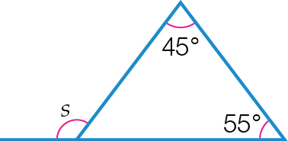

*s* = 45 + 55

*s* = 100°

Question 2 [6.2]

C

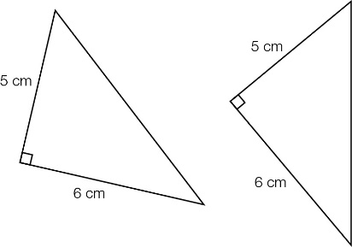

There are two pairs of congruent sides with an included equal angle.

SAS

Question 3 [6.4]

A

The dimensions of the photo are 40 mm by 30 mm.

The A4 is 297 mm by 210 mm.

An appropriate scale factor is 7.

7 × 40 = 280 mm by 7 × 30 = 210 mm

Question 4 [6.3]

C

A rhombus is a parallelogram with no right angles and four equal side lengths.

Question 5 [6.1]

A

|  |  |
| --- | --- |
| C:\Users\Maja\AppData\Local\Microsoft\Windows\INetCache\Content.Word\PM2e_09_EB_06_AT_02.jpg | By drawing alternate angles:  alternate angle = 35°  co-interior angle = 60°  35° + 60° = 95° |

Question 6 [6.5]

A

|  |  |
| --- | --- |
| *C:\Users\Maja\AppData\Local\Microsoft\Windows\INetCache\Content.Word\PM2e_09_EB_06_AT_03.jpg* | and |

Question 7 [6.1]

D

Co-interior angles add to 180°.

Question 8 [6.3]

D



Question 9 [6.7]

C

A solid with a cross-section is a prism and the cross-section is a triangle. Therefore this is a triangular prism.

Question 10 [6.3]

B

The properties of the angles of a kite show two pairs of equal side lengths, which are joined by diagonally opposite equal angles.

Question 11 [6.4]

A

*A′B′* = 0.5 × 1.6 = 0.8 cm

Question 12 [6.6]

D

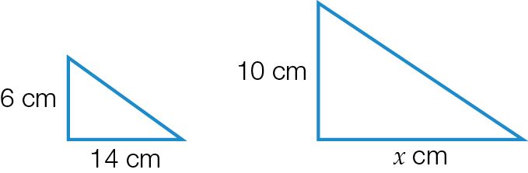



Multiple-choice total marks: 12

Short answer section

Question 13 6 marks [6.3]

(a)

|  |  |
| --- | --- |
| C:\Users\Maja\AppData\Local\Microsoft\Windows\INetCache\Content.Word\PM2e_09_EB_06_AT_04.jpg | 5*s* + 25 + 85 + 28 + 22 = 540°  5*s* + 160 = 540°  5*s* = 540 – 160  5*s* = 380 |

(b)

|  |  |
| --- | --- |
| C:\Users\Maja\AppData\Local\Microsoft\Windows\INetCache\Content.Word\PM2e_09_EB_06_AT_05.jpg | *a* + 60 + 65 + 30 = 360°  *a* + 155 = 360°  *a* + 155 – 155 = 360° *–* 155  *a* = 205° |

(c)

|  |  |
| --- | --- |
| C:\Users\Maja\AppData\Local\Microsoft\Windows\INetCache\Content.Word\PM2e_09_EB_06_AT_06.jpg | Triangle *ABC* is an isosceles triangle: angles *A* and *B* are equal.  *A* = 180 – 80  = 100    = 50°  angle *B* = angle *A* = 50°  angle *B* in the quadrilateral = 130°  Therefore:  130 + 30 + 85 + *x =* 360°  245 + *x* = 360°  *x* = 360 – 245  *x* = 115° |

(d)

|  |  |
| --- | --- |
| C:\Users\Maja\AppData\Local\Microsoft\Windows\INetCache\Content.Word\PM2e_09_EB_06_AT_07.jpg | *q =* 56 + 92  *q =* 148° |

(e)

|  |  |
| --- | --- |
|  | 3*x* = 180°    *x =* 60° |

(f)

|  |  |
| --- | --- |
| **C:\Users\Maja\AppData\Local\Microsoft\Windows\INetCache\Content.Word\PM2e_09_EB_06_AT_09.jpg** | *d* + 120 + 120 + 90 + 90 = 540°  *d* + 420 = 540°  *d* = 540 – 420  *d* = 120° |

Question 14 4 marks [6.5]

(a)

|  |  |
| --- | --- |
| ACPM9_PR_6_03ta |  |

(b)

|  |  |
| --- | --- |
|  |  |

Question 15 3 marks [6.6]

(a)

|  |  |
| --- | --- |
|  |  |

(b)

|  |  |
| --- | --- |
|  | ∠*Q* is common.  Given that *TR* || *SP* then ∆*TQR* ⫼ ∆*PQS* by AAA  therefore |

Question 16 4 marks [5.4]

**(a)** The scale factor is: 

**(b)**



**(c)**



Question 17 4 marks [6.5]

**(a)**

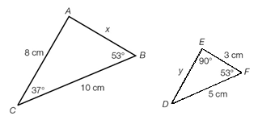

∠*A* = 180 – 37 – 53 = 90°

∠*D* = 180 – 90 – 53 = 37°

Therefore ∆*ABC* and ∆*DEF* are similar, with three equal angles (AAA).

**(b)**

 

Question 18 4 marks [6.5,6.6]

**(a)** ∠*RPQ* = ∠*RST*

∠*R* is common.

Therefore ∆*RPQ* ⫼ ∆*RST* by AAA.

**(b)** 

*x*(*x* + 2) = 24



Question 19 2 marks [6.7]

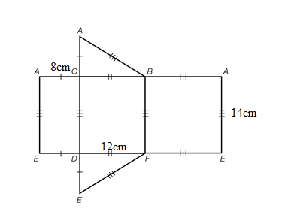

Question 20 1 mark [6.3]

A rectangle has two pairs of parallel lines. The opposite sides are equal in length and are perpendicular.

A square has all the same properties. All four of the side lengths are equal in length.

Question 21 3 marks [6.1]

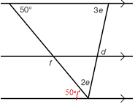

By considering the co-interior angles:



Angles 3*e* and *d* are alternate and are therefore equal.



Angle *f* is co-interior to 50°, which means *f* = 180 – 50 = 130°.

Question 22 4 marks [6.1]

**(a)** A straight angle is made from the sum of the angles:



**(b)** The angles are co-interior and therefore add to 180°.



**(c)** The two angles are co-interior.

Therefore:



Given that *x* = 30° and *y* = 40°, the equation becomes:



Question 23 3 marks [6.2]

**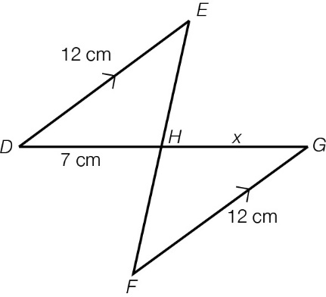**

∠*HGF* = ∠*EDH* (alternate angles)

*DE* = *FG*

∠*GFH* = ∠*DEH* (alternate angles)

Therefore ∆*DEH* ≡ ∆*GFH* by ASA and *x* = 12 cm

Question 24 3 marks [6.6]

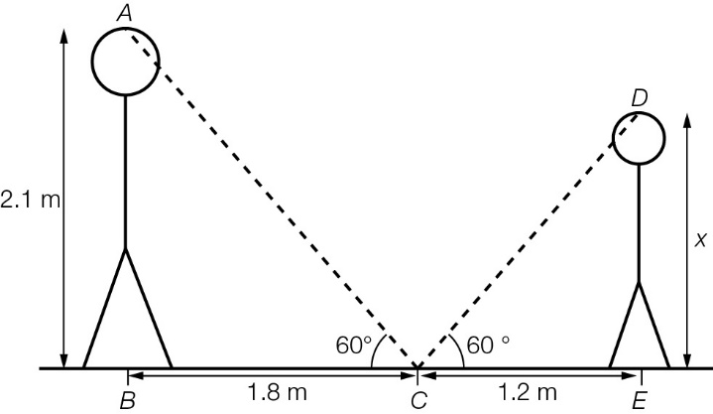

The two figures are perpendicular to the ground which gives ∠*ABC* = ∠*DEC* = 90°. The triangles form an angle at the ground equal to 60°, so ∠*ACB* = ∠*DCE*, which creates two similar triangles by AAA.



Christy is 1.4 metres tall.

Short answer total marks: 40

Extended answer section

Question 25 3 marks [6.3]



A 20-sided shape has interior angles of 162°.

Question 26 4 marks [6.6]

|  |  |
| --- | --- |
| C:\Users\Maja\AppData\Local\Microsoft\Windows\INetCache\Content.Word\PM2e_09_EB_06_AT_16.jpg | (a) *PQS* = ∠*RQT* (vertically opposite)  ∠*PSQ* = ∠*RTQ* = 90°  ∠*TRQ* = ∠*SPQ* (alternate angles)  Therefore ∆*PSQ* ~ ∆*RTQ*  **(b)**  The river is 16 m wide. |

Question 27 3 marks [6.5]

(a) 

The scale factor from ∆ABC to ∆*KLM* is 0.5.

**(b)**

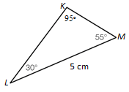

Question 28 2 marks [6.4]

The original triangle has the area *A1* = *bh*. The new triangle has the dimensions  of the length.



Therefore *A*2 = 45 ÷ 9 = 5 cm2.

Question 29 1 mark [6.3]

Create a line parallel to the base of the isosceles triangle.

Question 30 4 marks [6.6]

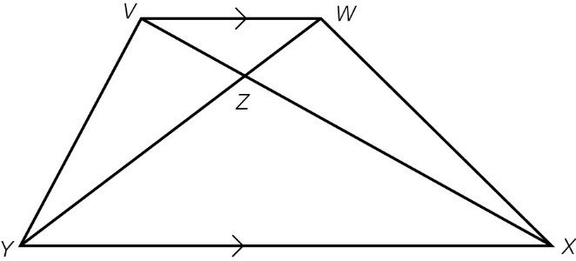

**(a)** ∠*VZW =* ∠*XZY* (vertically opposite angles)

∠*VWZ* = ∠*ZYX* (alternate angles, *VW* || *YX*)

∠*WVZ* = ∠*ZXY* (alternate angles, *VW* || *YX*)

Therefore ∆*VWZ* ⫼ ∆*XYZ* by AAA

**(b)** ∠*VZY* ≠ ∠*VZW* except when ∠*VZW* = 90° (supplementary angles)

These are the only pairs of angles that you have any information about, and no information is given about the lengths of the sides, so there is insufficient information to allow you to say that the triangles are similar.

If ∠*VZW* = 90° and *WZ* = *YZ*, ∆*VYZ* ≡ ∆*WXZ* by SAS

**(c)** If *VY* = *WX* and ∠*VYX* = ∠*WXY, XY* is common to both ∆*VYX* and ∆*WXY*.

Therefore ∆*VYX* ≡ ∆*WXY* by SAS

**(d)** For *VY* = *WX* (given in part **(c)**)

∆*VYX* ≡ ∆*WXY* then ∠*YVX* = ∠*XWZ* (matching angles in congruent triangles)

∠*WZX* = ∠*VZY* (vertically opposite angles)

Therefore ∆*VYZ* ≡ ∆*WXZ* by ASA

Question 31 4 marks [6.6]

**(a)** In ∆*ABC* and ∆*AED*

∠*ADE* = ∠*ACB* (given)

∠*BAC* =∠*EAD* (common angle)

∠*AED* = ∠*ABC* (angle sum of triangle)

∴ ∆*ABC* ~ ∆*AED* (AAA)

**(b)** *DE* is not parallel to *BC* as the pair of equal angles do not form a pair of corresponding angles.

**(c)** ∠*BDE* + ∠*ECB* = ∠*BDE* + ∠*ADE* = 180° (straight angle)

Question 32 3 marks [6.6]

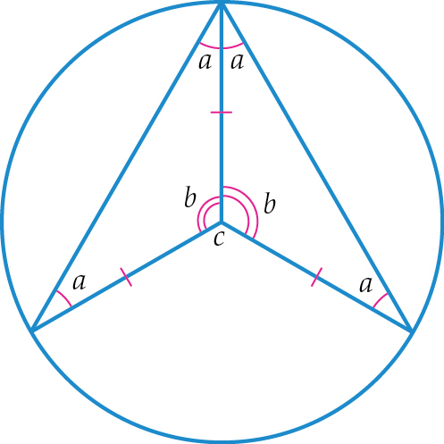

By cutting the top angle in half, create two isosceles triangles with the radii as the two equal sides.

*b* = 180 – 2*a*

And *c* = 360 – 2*b*

Substitute the expression for *b*:

*c* = 360 – 2(180 – 2*a*)

= 360 – 360 + 4*a*

= 4*a*

So the angle at the centre is twice the size of the angle at the circle.

*m* = 2 × 42 = 84°

Therefore *A*2 = 45 ÷ 9 = 5 cm2

Extended answer total marks: 24

TOTAL test marks: 76